 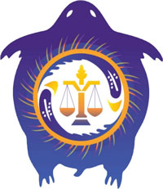 

AGENDA

**Friday, March 6, 2020**

9:00-9:30 Registration

9:30-10:30 Opening Ceremony

10:30-12:00 Facilitated Team Discussions.

12:00-1:00 Lunch

1:00-5:00 Facilitated Team Discussions (with breaks as determined by the room).

Evening- Up to you

Coaches/Facilitator Reception- TDS Lounge

**Saturday, March 7, 2020**

9:30-12:00 Facilitated Discussions

12:00-1:00 Lunch

1:00-2:30 Facilitated Discussions

3:00-4:00 Reporting of Each Group on Outcomes

6:30 forward Feast at Museum for Human Rights/Closing Ceremony

END OF Program.